LOOM FOR SALE
Schacht Cranbrook Countermarche loom
Contact: weavingtafuni@gmail.com

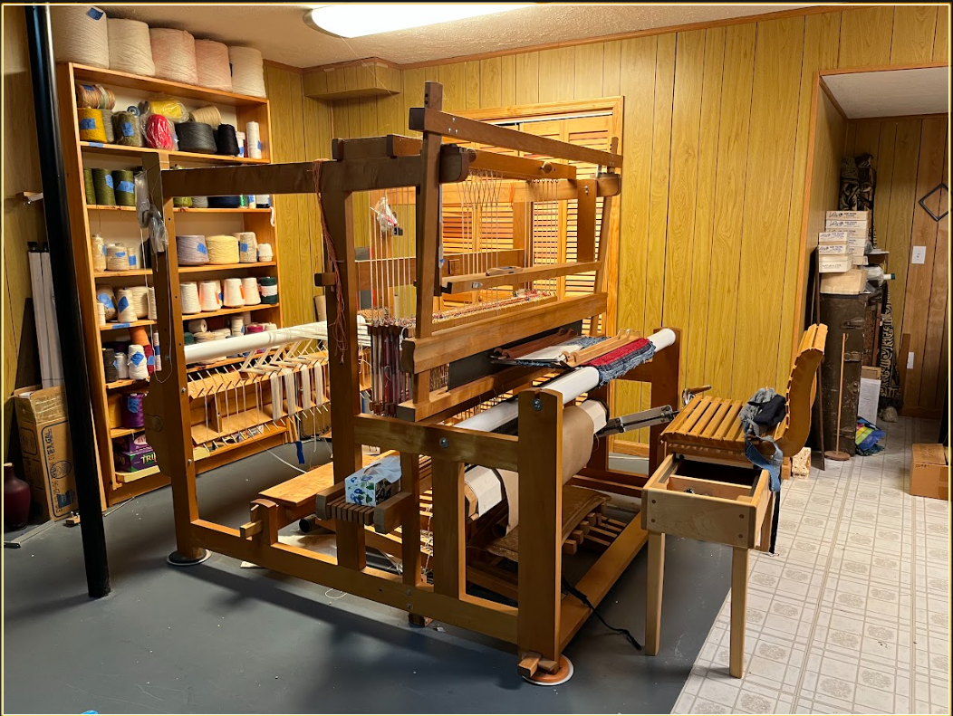
Dimensions: 69"wide, 77"deep, 71.5"high.
Loom has been lovingly maintained in a non-smoking environment and is in excellent shape. Loom has treadle locks, a fully adjustable beater with two sets of lamms (an upper suspended laam and a lower pivoting lamm).
The solid octagonal warp and cloth beams are 16 1/2" in circumference. The Cranbrook can be expanded from four to six or eight shafts at any time. Solid bronze ratchet gears, pawls, and beater hanger racks. The warp beam worm gear is released by a foot pedal. There are 10 treadles. Loom includes a sectional warp beam and tool tray, a sliding threading bench, rolling temples, 3 reeds, 8,10,12 ends per inch 48" wide. Loom also comes with mobile garden bench, 5 boat shuttles and raddle. Loom is available for pickup only in Churchville, Virginia.

