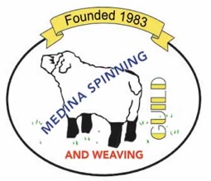 ROC DAY 2025

Join us for the Medina Spinning and Weaving Guild’s Annual Roc Day Celebration!

**Saturday, January 4, 2024**

**10 a.m.- 2 p.m.**

**Medina Presbyterian Church**

**5020 Burgundy Bay**

**Medina, OH. 44256**

We will have a gift giveaway, potluck lunch, and our annual event of making kitchen sink batts. Coffee and tea will be provided.

**PLEASE BRING:**

•A gift labeled for a spinner, dyer, weaver, felter, or any crafter

•A dish to share for our potluck lunch

•Your own table service- plate, bowl, silverware, coffee or drinking cup

•Donations to the church pantry- specifically personal hygiene items and peanut butter or jelly in plastic containers. Cash donations also accepted.

•Fiber for the kitchen sink batts activity

**PLEASE USE THE BACK PARKING LOT OF THE CHURCH**

Questions?

Contact Nancy Kilkenny- nancy.kilkenny28@gmail.com